**CHAPTER 1**

**INTRODUCTION**

Surveillance is the monitoring of the behavior, activities, or other changing information, usually of people for the purpose of influencing, managing, directing, or protecting them. Surveillance is the process of monitoring a situation, an area or a person. By monitoring the certain activities or areas every time using the surveillance system, the users are able to know if something abnormal happens and further action can be taken after that. This generally occurs in a military scenario where surveillance of borderlines and enemy territory is essential to a country’s safety. Human surveillance is achieved by deploying personnel near sensitive areas in order to constantly monitor for changes. But humans do have their limitations, and deployment in inaccessible places is not always possible. There are also added risks of losing personnel in the event of getting caught by the enemy. With advances in technology over the years, however, it is possibly to remotely monitor areas of importance by using robots in place of humans. Apart from the obvious advantage of not having to risk any personnel, terrestrial robots can also pick up details that are not obvious to humans. By equipping them with high resolution cameras and various sensors, it is possible to obtain information about the specific area remotely.

Robot is an electro-mechanical machine that is controlled by a computer program or electronic apparatus. It is being used to give convenience to human by doing specific task. The robotics and automation industry which is ruled the sectors from manufacturing to household entertainments. It is widely used because of its simplicity and ability to modify to meet changes of needs. Robots are able to execute the task that impossible or beyond capability of human. From this advantage, it can give many advantages in term of safety, ease and efficiency.

**1.1 Objective of This Project**

The aim of this project is to develop a surveillance mobile robot that able to visualize image on-site and works on manual as well as autonomous mode. This is carried out by the following objectives.

* To develop a mobile robot with autonomous and manual modes equipped with camera for monitoring system using microcontroller unit (MCU) with live video streaming.
* To create a control unit with MCU for navigation control in manual mode.
* To communicate the robot and control using Zigbee wireless technology.
* To provide low cost surveillance robot equipped with PIR senors, gas/smoke sensors for monitoring remote area.
* To identify the system requirements and user requirements and to arrive at the block diagram with all the necessary interfaces needed for the system along with modeling of the software algorithm.
* To implement the system on a suitable platform by assembling the peripherals, also building the algorithm to the system requirements and porting it.
* To test the individual modules (i.e. unit testing) as well as the combined system (i.e. integration testing.

**1.2 Scope of Project**

In order to achieve the objectives of the project, the scopes of work are identified as:

* Mobile robot with autonomous and manual modes.
* Limitation of controlling range is between 50 to 100 meters indoor area
* Working environment is flat surface
* Two DC motors are used for mobile robot movement
* Robot is equipped with gas/smoke sensor and PIR sensors.

**1.3 Problem Statement**

Currently, most of dangerous areas that should be monitored regularly often use the Closed-Circuit Television (CCTV) system as the medium of monitoring operation. However, this CCTV used a static camera where it is difficult to transmit the image on-site effectively because of single viewing angle for each CCTV installed. Due to this problem, manpower is used to gives a direct view to get the desired image which is indirectly endanger to the safety of human being. Dangerous environment such as radiation, high temperature, flammable and etc will risk the human life. Their safety is not guaranteed if they are directly used to execute the monitoring task. Also the designed robots can be used for human rescue during disasters and in war fields with the help of PIR sensor and IP camera.

**1.4 Outline of Report**

This report consists of six chapters and organized as follows.

In Chapter 1, the introduction section will be briefly explained about the background of the project generally. The problem statement, objective and scope of the project also being stated in this first chapter.

In Chapter 2, literature review of the project is summarized where the background studies over the previous project developed by others is stated. Some critical review is discussed in this chapter.

Methodology is briefly explained in Chapter 3 on how the project is approached and executed. Project planning is clearly stated here. Process flow of the project also included in this chapter.

Chapter 4 discussed the result of the project.

Advantages and applications of the project are discussed in Chapter 5.

In chapter 6, the overall performance is concluded and future scopes are discussed.

**CHAPTER 2**

**LITERATURE SURVEY**

In this chapter, the similar previous projects that developed by others is reviewed and discussed to give critical review and also to choose the suitable equipment and method before starting the project implementation.

Presently, an intelligence surveillance system is in high demand where the traditional ways of monitoring system which using CCTV resulting an ineffective image due to its static position. Several projects have been done to overcome the problem and one of the basic idea is developing a surveillance mobile robot. Several related project is reviewed as follows.

1. **Autonomous Explorer Mobile Robot**

The previous project by Csongor Márk Horváth and Róbert Tamás Fekete in their article "Development of Autonomous Explorer Mobile Robot for a Specific Environment" on 2011 is using the same basic concept as the *Surveillance Robot* where a mobile robot is equipped with a camera but the robot is used for exploring purpose instead of monitoring. Figure 2.1 below shows the Autonomous Explorer Mobile Robot.

In this project, the robot is controlled by ATMEL ATmega128 microcontroller. It is a fully automated type of robot where it consists of sonar sensor for obstacle avoiding and infrared sensor for a wall following function. The mobile robot used a wireless camera in order to transmit the image captured on-site to a monitoring station. This robot does not use a communicating device such as RF transceiver to manually control by a computer. It only used a Wi-Fi network to connect the robot and computer. This mobile robot is fully depends on the Wi-Fi access point that determine its covering area which gives some disadvantages where this robot only able to operate in a Wi-Fi network environment.

1. **Remote Controlled Surveillance Mobile Robot with IP Camera**

The *Remote Controlled Surveillance Mobile Robot with IP Camera* was developed by Gilbert, Martin and Janssen in 2011. This manually-operated mobile robot using PIC 16F877A microcontroller and equipped with wireless IP Camera. This surveillance mobile robot also being control by user using a GUI console created on a computer. As a connecting device, this robot used an RF Transceiver. Other additional function such as battery level indicator also included in this project.

1. **Surveillance Robot Using Arduino Microcontroller**

The *Surveillance Robot Using Arduino Microcontroller, Android APIs and the Internet* was developed by Chinmay Kulkarni, Suhas Grama, Pramod Gubbi Suresh, Chaitanya Krishna, Joseph Antony.

They proposed a cost-effective wheeled surveillance robot using an Arduino UNO microcontroller and a Smartphone running the Android Operating System. Surveillance robot

consisted of a video camera mounted on servo. Android smart phones come with excellent hardware satisfying the above needs. This used advantage through APIs (Application Programming Interfaces) provided for the Android operating system. Moreover, the cost for building said robot using a Smartphone is mitigated to a great extent. The robot was controlled remotely from a PC using the internet and a microcontroller-smart phone interface residing on the robot. To capture and archive the real time video from the robot, the inbuilt camera input of the phone was utilized. The robot was controlled based on visual feedback from the same smart phone.

1. **Android Spybot**

The *Android Spybot* by Erik Bruckner, Jason Kelch, Sam Chang in 2015

The project was involved in development of an advance mobile surveillance platform that can quickly be deployed in the field with minimal cost and training. This was achieved using readily available commercial off the shelf parts for the chassis and drivetrain, as well as all electronic components. The user interface was designed to provide an immediate sense of familiarity that allows for easy use, even with minimal training. This objective was achieved using two cell phones, one mounted to the robot that sends video, and another to control the robot and receive the video. This will provide a simple, yet effective tool to enhance reconnaissance and security monitoring.

1. **Multiple Sensors Based Fire Extinguisher Robot**

The *Multiple Sensors Based Fire Extinguisher Robot Based on DTMF, Bluetooth and GSM Technology with Multiple Mode of Operation* by Humayun Rashid, Iftekhar Uddin Ahmed, Aasim Ullah, MD. Fahim Newaz, Mohammad Sijanur Rahaman Robin, S M Taslim Reza in 2016.

In this project, design and development of a multiple sensors based fire extinguisher robot was proposed and implementation is demonstrated with a brief discussion of construction and operation. The developed fire extinguisher robot was operated in multiple modes using the DTMF and Bluetooth remote control as well as GSM and GPS technology. The three different sensors of flame sensor, temperature sensor, and smoke sensor have been used to ensure proper detection of fire. The robot was controlled using both DTMF remote control and Android Smartphone and can be operated in three different modes. The first mode allows full autonomous operation of the robot which can be activated by the user or by the robot itself based on the situation. The second mode is a line following mode where robot follows a black drawn line to detect fire and the third mode is complete manual operation using remote control.

1. **Semi-autonomous Mobile Rescue Robot**

The *Search and Rescue System for Alive Human Detection by Semi-autonomous Mobile Rescue Robot* by Zia Uddin, Mojaharul Islam on 2016. In this paper, PIR sensor based semi-autonomous mobile rescues robot was developed which can detect live human being from an unreachable point of the disaster area. Joystick and RF technology is used to control the semi-autonomous robot and communicate with control point. Ultrasonic sensor is used for obstacle detection in navigation path of robot and gas sensor is used to detect gas leak inside the building. IP Camera is also integrated to observe and analyze conditions that will facilitate human detection in reliable manner with highest probability of success rate in that kind of situation.

**Table 2.1** Summary of literature survey

|  |  |  |  |
| --- | --- | --- | --- |
| **Paper** | **Authors name** | **Advantages** | **Disadvantages** |
| 1. Autonomous explorer mobile robot | Csongor Márk Horváth and Róbert Tamás Fekete | Manually controlled using WI-FI and has night vision camera | No Automode and  WI-FI range is limited |
| 2. Remote controlled  Surveillance Mobile Robot with IP Camera | Gilbert, Martin and Janssen | Robot is controlled using GUI | Supports only manual operation |
| 3. Surveillance Robot Using Arduino Microcontroller | Chinmay Kulkarni, Suhas Grama, Pramod Gubbi Suresh, Chaitanya Krishna, Joseph Antony. | Autonomous robot | No manual control |
| 4.Android Spybot | Erik Bruckner, Jason Kelch, Sam Chang | Controlled using Android API | Bluetooth range is limited |
| 5. Multiple Sensors Based Fire Extinguisher Robot | Humayun Rashid, Iftekhar Uddin Ahmed, Aasim Ullah, MD. Fahim Newaz, Mohammad Sijanur Rahaman Robin, S M Taslim Reza | Supports multiple modes | Remote control is works on Bluetooth whose range is limited |
| 6. Semi-autonomous Mobile Rescue Robot | Zia Uddin, Mojaharul Islam | It has PIR and Smoke sensors  used as rescue system in disaster | No automatic mode and RF range is limited |

**CHAPTER 3**

**DESIGN AND IMPLEMENTATION**

**3.1 Outcomes of Literature review**

The outcomes of the literature review serve as a solid platform for getting started with design phase of the mobile surveillance system. Some of the highlighting parameters that were noted from the literature are

* It was concluded from the existing literature the robots have only one mode of operation.
* The literature reveals the need for providing low cost and user friendly mobile surveillance system. The existing products are costly and non-reliable.
* The existing systems works on low power Bluetooth technology or RF which gives very less range.

Thus the features of the current system for incorporating all the parameters listed will include:

1. The robot is autonomous and can also be controlled using controller.
2. Robot uses Ultrasonic sensor mounted on servo in autonomous mode to watch around for obstacle.
3. Robot incorporates Zigbee modules for wireless control.
4. The Mobile robot is equipped with an IP camera which transmits live video data to locally connected PC.
5. Passive Infrared Sensor and Smoke sensors are used to alert the base station with the respective information about gas leakage and human movements.
6. In manual mode, it can be used as a rescue system and PIR senses the alive human in the place of disaster.

**3.2 Functional Block Diagram**

The design consists of a surveillance robot and a control unit. The functional block diagram for the proposed system with adequate peripheral interfaces is shown in **Figure 3.1**.

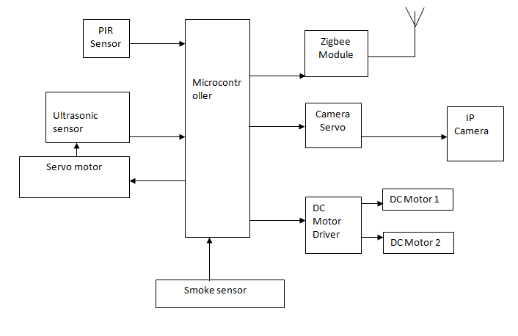

**Figure 3.1a Block diagram of Robot**

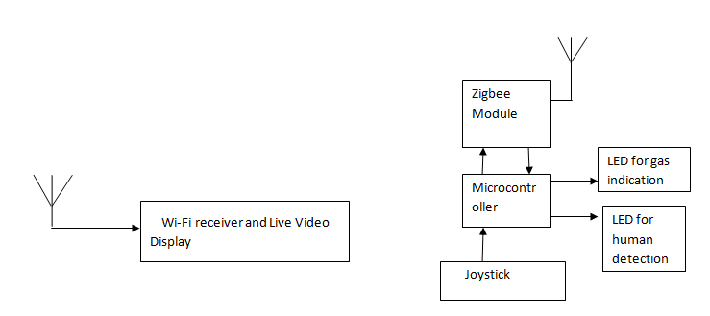

**Figure 3.1b Block diagram of Control Station**

As shown in the figure 3.1 robot works with two modes. That is, autonomous and manual. Ultrasonic sensors are used in autonomous mode, for obstacle detection and travel around the prescribed free path. Robot is equipped with IP camera that is capable of sending video information to a locally connected computer. Ultrasonic sensor is mounted on servo motor to watch around for obstacle. For manual mode robot is connected to base station using zigbee modules. Control station is provided with joystick for controlling the movement of robot. The surveillance robot continuously capture and streams the video data to the host computer and is also provided with PIR and gas sensors. PIR sensors used for human motion detection which can be used to watch human motion in hardware and line control. Whenever human motion detected or a smoke is detected base station is alerted using zigbee. MQ-2 gas sensor has high sensitivity to LPG, Propane and Hydrogen, also could be used to Methane and other combustible steam, it is with low cost and suitable for different application.

**3.3 System flow diagram**

**Flowchart for processing logic of robot and control unit is as shown in Figure 3.2**

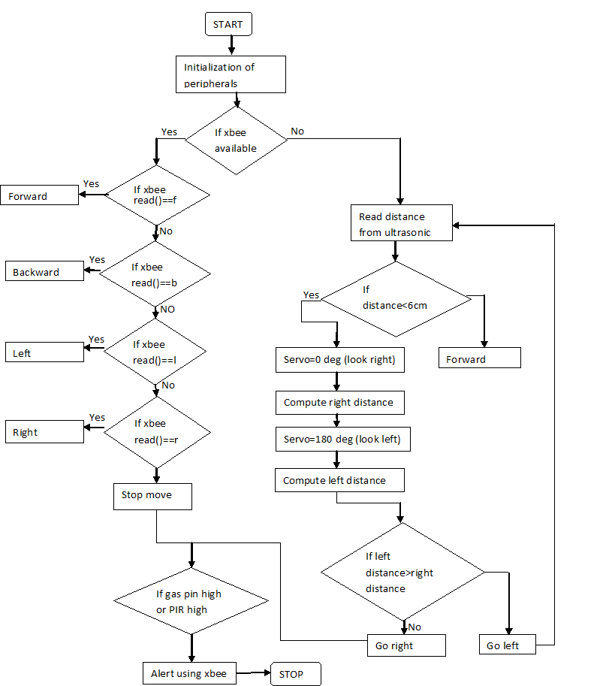

**Figure 3.2 a Flowchart for processing logic platform for robot**

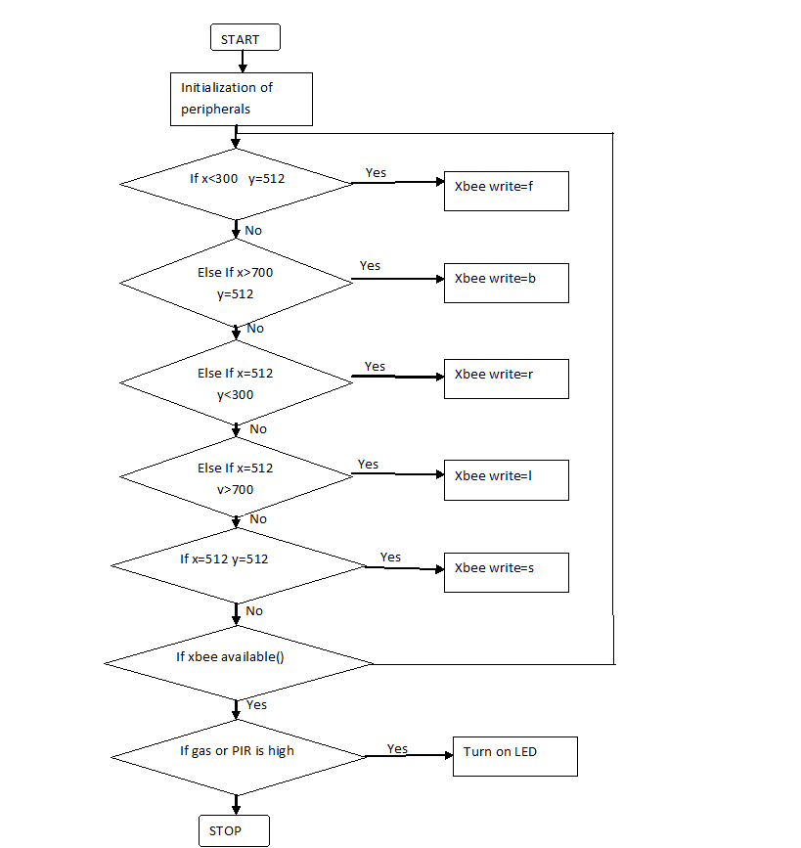

**Figure 3.2b Flowchart for processing logic platform for control unit**

**3.4 Implementation details**

The algorithm implementation was carried out in Arduino 1.8.2 IDE using C language and some Arduino specific constructs for deployment on Arduino Mega 2560 and Arduino UNO R3 platform. Arduino Mega 2560 is used in robot model and Arduino Uno R3 is used in control unit.

**3.4.1 Robot Implementation**

**1. Board Specifications:**

The ***Arduino Mega 2560*** figure is a microcontroller board based on the ATmega2560 (datasheet). It has 54 digital input/output pins (of which 14 can be used as PWM outputs), 16 analog inputs, 4 UARTs (hardware serial ports), a 16 MHz crystal oscillator, a USB connection, a power jack, an ICSP header, and a reset button. It contains everything needed to support the microcontroller; simply connect it to a computer with a USB cable or power it with a AC-to-DC adapter or battery to get started.

Microcontroller ATmega2560

Operating Voltage 5V

Input Voltage (recommended) 7-12V

Input Voltage (limits) 6-20V

Digital I/O Pins 54 (of which 14 provide PWM output)

Analog Input Pins 16

DC Current per I/O Pin 40 mA

DC Current for 3.3V Pin 50 mA

Flash Memory 256 KB of which 8 KB used by boot loader

SRAM 8 KB

EEPROM 4 KB

Clock Speed 16 MHz

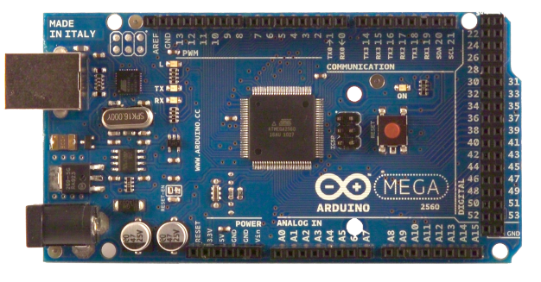 **Figure 3.3 Arduino Mega 2560**

**2. Ultrasonic sensor** used in the robot is as shown in the below Figure 3.4

An Ultrasonic sensor is a device that can measure the distance to an object by using sound waves. It measures distance by sending out a sound wave at a specific frequency and listening for that sound wave to bounce back. By recording the elapsed time between the sound wave being generated and the sound wave bouncing back, it is possible to calculate the distance between the sonar sensor and the object.

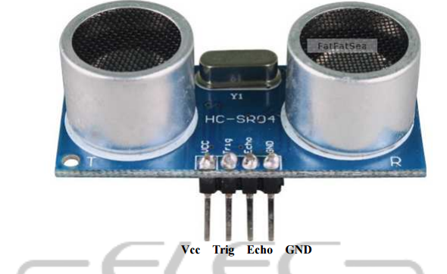

**Figure3.4 Ultrasonic Sensor HC - SR04**

**Table 3.1 Ultrasonic sensor Specification**

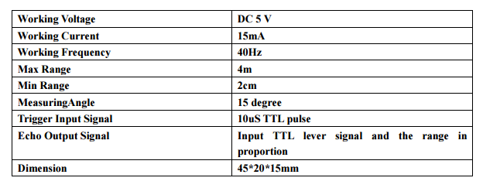

Ultrasonic transducers convert ultrasound waves to electrical signals and vice versa. These devices work on a principle similar to that used by transducers in radar and sonar systems, which evaluate the attributes of the target object by processing the echo signals from radio or sound waves, respectively.

**Working of Ultrasonic sensor**

Ultrasonic sensors consist of two parts: transmitter and receiver, which create a transducer that converts ultrasound waves into electrical signals (A/C) or vice versa. The transceiver vibrates and creates an ultrasonic wave that is transmitted and travels until it hits an object and is reflected back to the receiver. The interval between the signal being sent and received is typically referred to as time-of-flight (ToF) and depends on the distance the ultrasonic wave travels until it is reflected. The basic equation: time is equal to distance divided by speed, can be used to measure fluid level, fluid identification/concentration and distance.

The transceiver vibrates and creates an ultrasonic wave using piezoelectric transducers or capacitive transducer technologies. Piezoelectric crystals change size and shape when a voltage is applied: A/C voltage makes them oscillate at the same frequency and produce ultrasonic sound. Capacitive transducers use electrostatic fields between a conductive diaphragm and a backing plate. A single ultrasonic transducer can both generate and receive a signal, but the two functions are often separated in order to optimize the performance of each task.

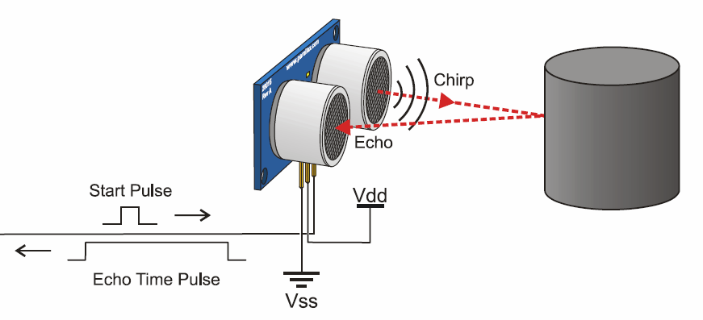

**Figure 3.5** Working of ultrasonic sensor

Ultrasonic sensors are ideal tools for measuring distance without requiring contact with the object and are an efficient method of precisely measuring small distances. As the distance from the object is proportional to the time interval between transmitting and receiving signals, a simple analysis of this data can reveal changes in the sensor’s distance to the object.

**3.** Two **Servo motors** are used in the robot. One to rotate Ultrasonic sensor and the other to rotate IP camera.

A servo motor is a rotary actuator that allows for precise control of angular position. It consists of a motor coupled to a sensor for position feedback. It also requires a servo drive to complete the system. The drive uses the feedback sensor to precisely control the rotary position of the motor. This is called closed-loop operation.

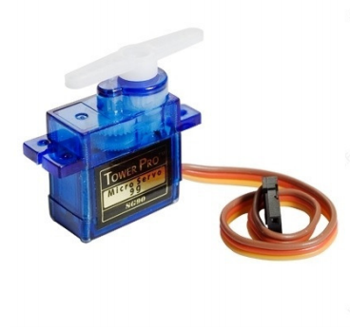 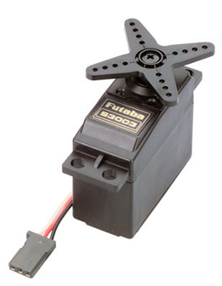

**Figure 3.6a Servo 90g used for Sonar Figure 3.6b Servo used for IP camera**

**4. Mq2 gas** sensor Figure 3.5 is used for smoke and gas detection that helps to monitor the surveillance area**.** MQ-2 gas sensor has high sensitive to LPG, Propane and Hydrogen, also could be used to Methane and other combustible steam, it is with low cost and suitable for different application.

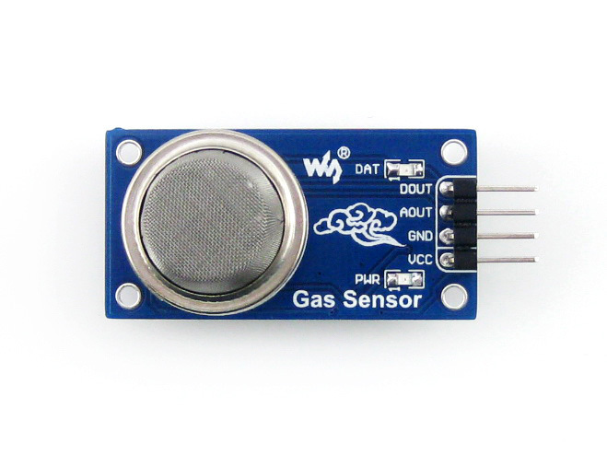

**Figure 3.7 MQ2 Gas sensor**

Sensitive material of MQ-2 gas sensor is SnO2, which with lower conductivity in clean air. When the target combustible gas exist, the sensor’s conductivity is more higher along with the gas concentration rising. Please use simple electronic circuit, Convert change of conductivity to correspond output signal of gas concentration. The Grove - Gas Sensor(MQ2) module is useful for gas leakage detection (home and industry). It is suitable for detecting H2, LPG, CH4, CO, Alcohol, Smoke or Propane. Due to its high sensitivity and fast response time, measurement can be taken as soon as possible. The sensitivity of the sensor can be adjusted by potentiometer.

This is an Analog output sensor. It needs to be connected to any one Analog socket in Grove shield. The examples used in this tutorial make uses of A0 analog pin. Connect this module to the A0 port of Base Shield.

It is possible to connect the Grove module to Arduino directly by using jumper wires, please refer to the connection in the table below:

**Table 3.2** Pin connection for MQ2 sensor

| **Arduino** | **Gas Sensor** |
| --- | --- |
| 5V | VCC |
| GND | GND |
| NC | D0 |
| Analog A0 | A0 |

**Table3.3 Technical Specification of MQ2**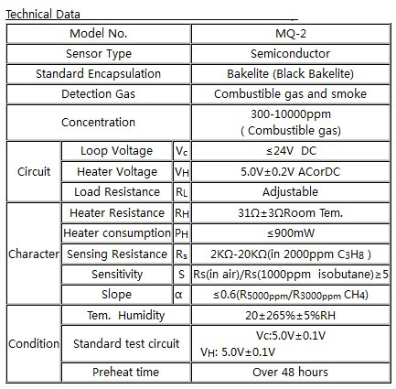

**5. Passive Infrared sensor** used for motion alerts is as shown below Figure 3.6

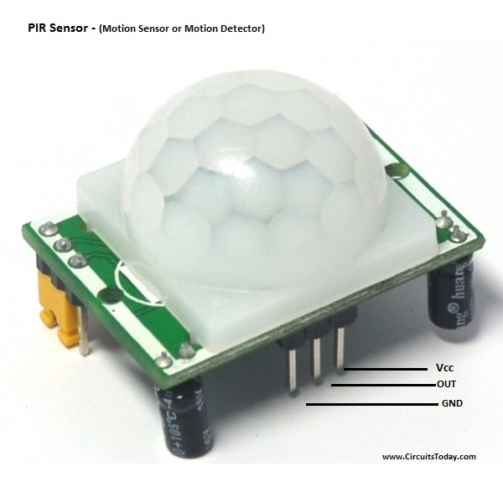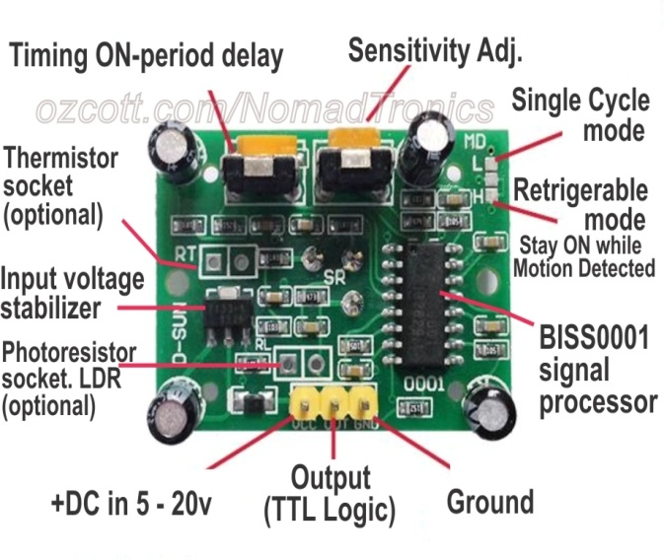

**Figure 3.8** Passive Infrared Sensor

A **passive infrared sensor** (**PIR sensor**) is an electronic sensor that measures infrared (IR) light radiating from objects in its field of view. They are most often used in PIR-based motion detectors.

All objects with a temperature above absolute zero emit heat energy in the form of radiation. Usually this radiation isn't visible to the human eye because it radiates at infrared wavelengths, but it can be detected by electronic devices designed for such a purpose.

The term *passive* in this instance refers to the fact that PIR devices do not generate or radiate any energy for detection purposes. They work entirely by detecting the energy given off by other objects.PIR sensors don't detect or measure "heat"; instead they detect the infrared radiation emitted or reflected from an object.

**Specifications**

1. working voltage range :DC 4.5-20V
2. Quiescent Current :50uA
3. high output level 3.3 V / Low 0V
4. Trigger L trigger cannot be repeated / H repeated trigger
5. circuit board dimensions :32 * 24 mm
6. maximum 110 ° angle sensor
7. 7 m maximum sensing distance

**6.** Two **Dc Motors** are used for the robot movements. The dc motors used are geared with 100 rpm speed. A DC motor is any of a class of rotary electrical machines that converts direct current electrical energy into mechanical energy. The most common types rely on the forces produced by magnetic fields. Nearly all types of DC motors have some internal mechanism, either electromechanical or electronic, to periodically change the direction of current flow in part of the motor. Since they require high direct current motor drivers are used. Here we have used L293D driver is used. L293D is a typical Motor driver or Motor Driver IC which allows DC motor to drive on either direction. L293D is a 16-pin IC which can control a set of two DC motors simultaneously in any direction. It means that you can control two DC motor with a single L293D IC. Dual H-bridge Motor Driver integrated circuit (IC).

It works on the concept of H-bridge. H-bridge is a circuit which allows the voltage to be flown in either direction. As you know voltage need to change its direction for being able to rotate the motor in clockwise or anticlockwise direction, hence H-bridge IC are ideal for driving a DC motor.

In a single L293D chip there are two h-Bridge circuit inside the IC which can rotate two dc motor independently. Due its size it is very much used in robotic application for controlling DC motors. Given below is the pin diagram of a L293D motor controller.

There are two Enable pins on l293d. Pin 1 and pin 9, for being able to drive the motor, the pin 1 and 9 need to be high. For driving the motor with left H-bridge you need to enable pin 1 to high. And for right H-Bridge you need to make the pin 9 to high. If anyone of the either pin1 or pin9 goes low then the motor in the corresponding section will suspend working. It’s like a switch.

There are 4 input pins for l293d, pin 2,7 on the left and pin 15 ,10 on the right as shown on the pin diagram. Left input pins will regulate the rotation of motor connected across left side and right input for motor on the right hand side. The motors are rotated on the basis of the inputs provided across the input pins as LOGIC 0 or LOGIC 1.

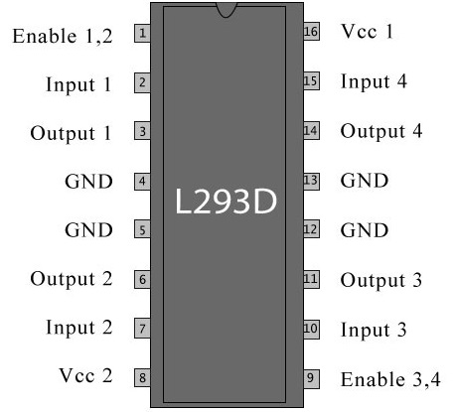

**Figure 3.9 Pin diagram of L293D**

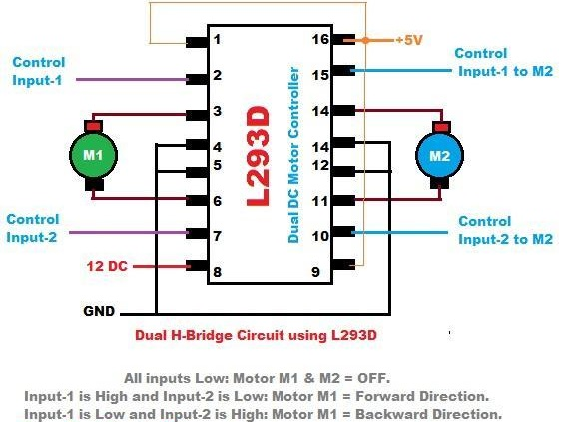

**Figure 3.10 Circuit Diagram For l293d motor driver IC controller.**

**7. Zigbee** Modules are used for wireless control of the robot. **Zigbee** is an IEEE 802.15.4-based specification for a suite of high-level communication protocols used to create personal area networks with small, low-power digital radios, such as for home automation, medical device data collection, and other low-power low-bandwidth needs, designed for small scale projects which need wireless connection. Hence, Zigbee is a low-power, low data rate, and close proximity (i.e., personal area) wireless ad hoc network.

The technology defined by the Zigbee specification is intended to be simpler and less expensive than other wireless personal area networks (WPANs), such as Bluetooth or Wi-Fi. Applications include wireless light switches, electrical meters with in-home-displays, traffic management systems, and other consumer and industrial equipment that requires short-range low-rate wireless data transfer.

Its low power consumption limits transmission distances to 10–100 meters line-of-sight, depending on power output and environmental characteristics.Zigbee devices can transmit data over long distances by passing data through a mesh network of intermediate devices to reach more distant ones. Zigbee is typically used in low data rate applications that require long battery life and secure networking (Zigbee networks are secured by 128 bit symmetric encryption keys.) Zigbee has a defined rate of 250kbit/s, best suited for intermittent data transmissions from a sensor or input device.

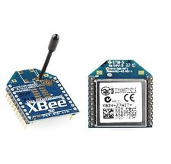

**Figure 3.11** Zigbee modules

Zigbee modules require 3.3v constant supply. So we have used breakout regulator boards for connecting Zigbee modules.

**Table 3.4** Zigbee S2C specifications

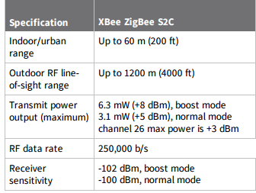

1. **Control unit** uses arduino uno board with a Zigbee module to control and receive the information from the robot. The Arduino Uno is a microcontroller board based on the ATmega328 (datasheet). It has 14 digital input/output pins (of which 6 can be used as PWM outputs), 6 analog inputs, a 16 MHz crystal oscillator, a USB connection, a power jack, an ICSP header, and a reset button.

**Board Specifications**

1. Microcontroller ATmega328
2. Operating Voltage 5V
3. Input Voltage (recommended) 7-12V
4. Input Voltage (limits) 6-20V
5. Digital I/O Pins 14 (of which 6 provide PWM output)
6. Analog Input Pins 6
7. DC Current per I/O Pin 40 mA
8. DC Current for 3.3V Pin 50 mA
9. Flash Memory 32 KB of which 0.5 KB used by bootloader
10. SRAM 2 KB
11. EEPROM 1 KB
12. Clock Speed 16 MHz

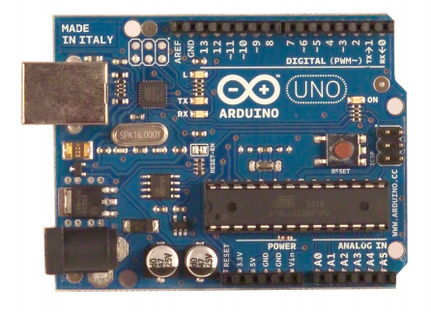

**Figure 3.12** Arduino Uno R3



**Figure 3.13** Joystick

1. The **joystick** in the base station using which the movements of the robot can be controlled.

The Joystick module is similar to analog joysticks found in gamepads. It is made by mounting two potentiometers at a 90 degrees angle. The potentiometers are connected to a short stick centered by springs.

This module produces an output of around 2.5V from X and Y when it is in resting position. Moving the joystick will cause the output to vary from 0v to 5V depending on its direction. If you connect this module to a microcontroller, you can expect to read a value of around 512 in its resting position (expect small variations due to tiny imprecision of the springs and mechanism) When you move the joystick you should see the values change from 0 to 1023 depending on its position.

**Specifications**

1. Directional movements are simply two potentiometers - one for each axis

2. Compatible with Arduino interface

3. The biaxial XY Joystick Module KY-023 applies ARDUINO

4. Dimensions: 1.57 in x 1.02 in x 1.26 in (4.0 cm x 2.6 cm x 3.2 cm)

5. 5 Pin

6. Color: Black

**Pin Configuration**

1. GND: ground

2. +5V: 5V DC

3. VRx: voltage proportional to x position

4. VRy: voltage proportional to y position

5. SW: switch pushbutton

1. Video data captured with the camera will be transmitted to base station. The camera used will be an **IP** camera which is capable of live video streaming to anywhere when connected to a router. An **Internet protocol camera** or **IP camera** is a type of digital video camera commonly employed for surveillance, and which can send and receive data via a computer network and the internet.

To reduce the cost of the project, smart phone driven with webcam app is used for video streming.

## CHAPTER 4

## RESULTS AND DISCUSSION

The robot is assembled by adding individual module with the breadboard. All the components except IP camera is interfaced with the microcontroller. The IP camera is attached with a servo motor to give 180 degrees of movement. The physical appearance of the robot is as shown in the below figure 4.1. The system is tested for confirming the basic functions and ability of the robot. Those experiments are performed in a realistic training scenario. From the experiment it is clear that the system is well functioning and can easily navigate through narrow path.

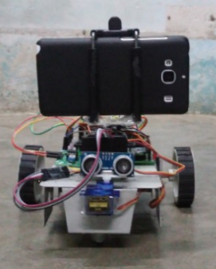

**Figure 4.1** Front view of Robot

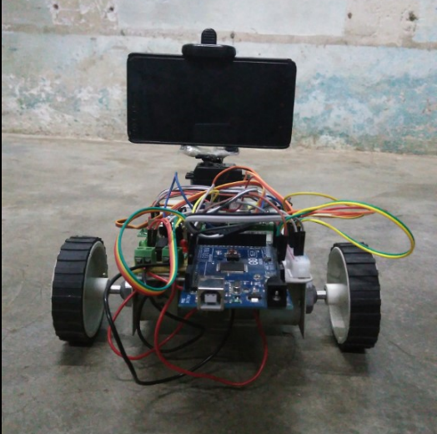

**Figure 4.2** Back view of the Robot

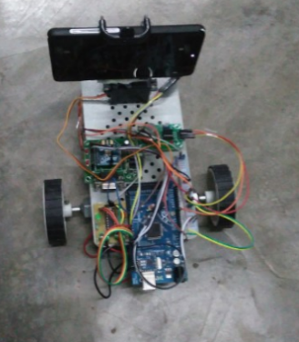

**Figure 4.3** Top view of the Robot

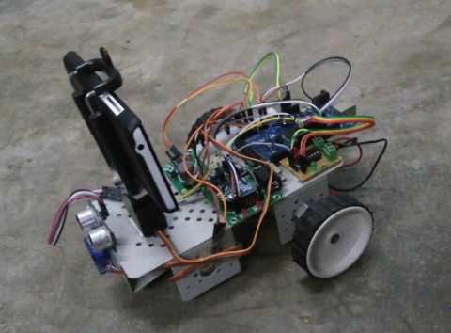

**Figure 4.4** Side view of the Robot

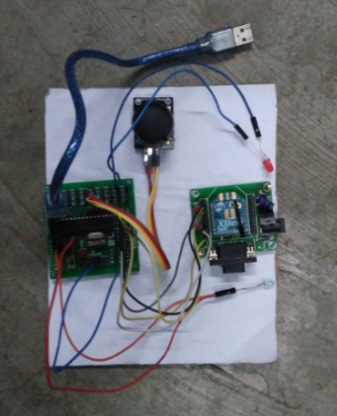

**Figure 4.5** Controller of the Robot

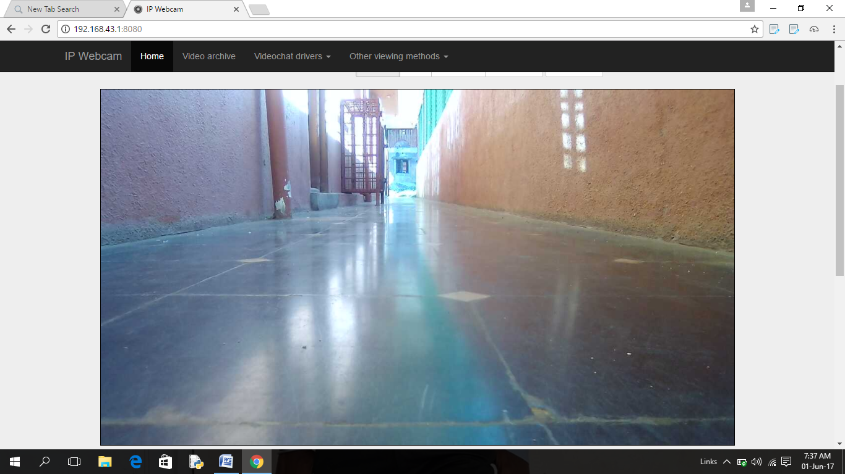

**Figure 4.6** Video terminal in computer

**CHAPTER 5**

**ADVANTAGES AND APPLICATIONS**

**5.1 ADVANTAGES**

* The surveillance robot has autonomous as well as manual modes of navigation.
* It has live video streaming that helps in observation and monitoring of sensitive areas.
* It uses Zigbee technology for wireless control, which has better range compared to RF communication.

**5.2 APPLICATIONS**

* Border Security
* Environmental Monitoring
* Emergency and Disaster Relief
* Critical Infrastructure Monitoring and Protection
* Wildlife Photography and Forest Surveillance
* Planet Exploration

**CHAPTER 6**

## CONCLUSION AND FUTURE SCOPE

**6.1 CONCLUSION**

This work is focused on the critical evaluation on the role and reliability of surveillance and security systems. Primary and secondary resources were used in the project execution. For the primary data, a survey has been conducted with the known existing Surveillance systems. Secondary resources derived from various publications including books and journals were integrated to support the findings. This system deals on the versatility and the usefulness of a mobile robot in the field of surveillance. Based on the results of the various test cases, system functionalities were validated. The test results agree that this solution is capable of providing a better surveillance in the cross-borders and it can be used as a rescue robot during disasters.

In addition, system has some other advantages. The integration of Arduino technology in administering this project also made this system a cost-effective product. The use of robots significantly expands the potential of surveillance systems, which can evolve from the traditional passive role, in which the system can only detect events to active surveillance, in which a robot can be used to interact with the environment, with humans or with other robots for more complex cooperative actions.

**6.2 FUTURE SCOPE**

* Adding explosive material Detector to track the path of Army and gunshot camera makes it suitable as a defense robot.
* Satellite communication control can be employed to increase the range of control.
* It can be provided with an electromechanical arm to take actions in critical conditions
* Safety features like collision alarm and low battery alarm.

# REFERENCES

1. T. Khoon, P. Sebastian and A. Saman, "Autonomous Fire Fighting Mobile Platform", Procedia Engineering, vol. 41, pp. 1145-1153, 2012.
2. IEEE journal “ Search and Rescue System for Alive Human Detection by Semi-autonomous Mobile Rescue Robot” by Zia Uddin and Mojaharul Islam
3. "Arduino – Arduino Board Mega2560", Arduino.cc [Online]. Available: [www.arduino.cc/en/Main/ArduinoBoardMega2560](http://www.arduino.cc/en/Main/ArduinoBoardMega2560)
4. "Carbon Monoxide & Flammable Gas Sensor MQ-2", www.pololu.com, 2016. [Online]. Available:www.pololu.com/file/0J314/MQ2.pdf.
5. "Ultrasonic Ranging Module HC - SR04",www.micropik.com, 2016. [Online]. Available: [www.micropik.com/PDF/HCSR04.pdf](http://www.micropik.com/PDF/HCSR04.pdf).
6. “Zigbee radio module S2C specifications reference” available at digisoul <https://www.digi.com/resources/documentation/digidocs/pdfs/90002002.pdf>
7. Servo motor voltage specifications and torque referece available online @ <http://www.micropik.com/PDF/SG90Servo.pdf>
8. L293x Quadruple Half-H Drivers source <http://www.ti.com/lit/ds/symlink/l293.pdf>
9. Range-based navigation system for a mobile Robot-Neil MacMillan, River Allen, DimitriMarinakis, Sue Whitesides, IEEE 2010
10. Smartphone-based Mobile Robot Navigation -Nolan Hergert, William Keyes, and Chao Wang,spring 2012
11. Development Of A Wireless Device Control Based Mobile Robot Navigation System PheySiaKwek,Zhan Wei Siew, Chen How Wong,, BihLiiChua, Kenneth Tze Kin Teo.IEEE 2012 [4]. A Bluetooth-based Architecture for Android Communication with an Articulated Robot- Sebastian van Delden, IEEE2013.
12. IP Webcam, Google Play Store [Online]:https://play.google.com/store/apps/details?id=com.pas.webcam&hl=en, February 2012.Indoor Surveillance Security Robot with a Self-Propelled Patrolling Vehicle, Volume 2011, Article ID 197105.
13. Android Developers Site API Guides: http://developer.android.com/guide/components/index.html, October2012
14. Phey Sia Kwek, Zhan Wei Siew, Chen How Wong, Bih Lii Chua and Kenneth Tze Kin Teo “DEVELOPMENT OF A WIRELESS DEVICE CONTROL BASED MOBILE ROBOT NAVIGATION SYSTEM” 2012 IEEE Global High Tech Congress on Electronics.
15. Pavan.C, Dr. B. Sivakumar “Wi-Fi ROBOT FOR VIDEO MONITORING & SURVEILLANCE SYSTEM” International Journal of Scientific & Engineering Research Volume 3, Issue 8, August-2012.
16. The Arduino Uno Website [Online]. Available: http://arduino.cc/en/Main/arduinoBoardUno, September 2012
17. L293D Datasheet- Texas Instruments – Quadruple Half- H Driver [Online] Available: http://www.alldatasheet.com/datasheetpdf/pdf/27189/TI/L293D.html, October 2012
18. Surveillance Robot Using Arduino Microcontroller, Android APIs and the Internet, 2014 First International Conference on Systems Informatics, Modelling and Simulation.
19. Shiffman, Daniel (2009). "Interview with Casey Reas and Ben Fry". Rhizome.org
20. Arduino Language Reference. Available: http://arduino.cc/en/Reference/HomePage, September 2012